Day1 [0.5 day] Working with Excel.

* Day 1Excel [How to create a dashboard in Excel]

* + Dynamic Data Set [ Working with Tables] Home Tab- Format as Table
  + Fetch the data from multiple dataset [VLOOKUP- False -0- Exact match, True- Approx. match range.. , Nested if Function ]
  + Create multiple Pivot Tables using single dataset [Sort, Filter, Group, Agg function]
    - Dept wise Total Emp
    - Salary wise Total Emp [0-5000,5000-10000…. Interval of 5000.. Right click on salary and select Group… by 5000..
    - Top 5 Emp based on salary [ Right on emp code and Filter – Top 10]
    - Bottom 5 Emp based on salary [ Right on emp code and Filter – Top 10 and change to bottom ] and sort the data on salary..
    - Year wise Total Emp [ Add Hire date- row label , and First name in value.. Right click on hiredate.. Group you select year and deselect other option
    - Dept wise Total emp and Total salary
    - Region wise Dept wise Total Emp / Total Salary / % of G.Total / % of Parent Total
  + Create multiple Charts
  + Add slicer to charts and connect to multiple pivot reports..
* **Excel Function**
  + Vlookup-match – [help to make row/col dynamic ]
  + Index- Match
  + Offset
  + Indirect

Day 2 [0.5 day] How to upload the data and create multiple reports in Power BI

Create Employee Information Dashboard Report and Publish on the Server

Connect to Excel Data and Create model in Power BI and create a Report and Publish on Power BI Server and Mobile App

* 1. Connect to Excel Data and add both the worksheet i.e. Salary and dept .
  2. Edit in Query view and check the data type of the field is as required.
  3. Create table ... for HRA Region wise East-1000, west-750, north-500, south-350
  4. Set the Relationship between different tables
  5. Create a new column and using Calculated Col calculated [like Vlookup and if]
     1. Add a New Column HraValue : RELATED(HRData[HRA])
     2. Add a New Column daValue : RELATED(HRData[HRA])
     3. Add a Col Sal+DA+HRA
     4. Add a New Column Tax using nested if function
     5. Tax =IF(Salary[Gross]>=15000,Salary[Gross]*.15,IF(Salary[Gross]>=10000,Salary[Gross]*.1,if(Salary[Gross]>=5000,Salary[Gross]*.05,0)))
     6. Net: Gross-Tax
     7. Add a Col of EmpName= [First Name] & “ “&[Last Name]
  6. Create a Report.

* + 1. Add Text box and Line and Format it
    2. Dept wise Total Emp [ Bar chart]
       1. Select Bar Chart… and add Dept and Empcode .. change to count
    3. Salary wise [details] Total Emp [ Use Group-Bin] [ Pie chart]
       1. Right click on Salary and create a group... give bin size 5000.
       2. So, one more filed be added known as Salarybins
       3. Create a Pie Chart and Add salary bins and Total Emp
    4. Year wise Total Emp [Group on Date Field]
       1. When we add date field .. internally group is created …
       2. Select only year and delete other fields and Total Emp.
    5. Top 5 Emp [Use Filter]
       1. Select Col Chart Add EmpName and salary field
       2. In Visual Filter … Select Top n filter add salary and apply
    6. Bottom 5 Emp
       1. Make a copy and change the filter from top to bottom
    7. Create a matrix report [Dept wise Total emp and Total Salary]
       1. Select the Matrix Visual and Region Dept, Total Emp and Total Salary
       2. Add one more time salary in values and change to % of G.Total
  1. Add a Slicer to Report .. add Region in Slicer and Format it

Creating Hierarchy Report / Drill Down Report

1. Create a Hir. on Date wise Report
   1. Add Col Chart and Add Date Field and Total Emp
   2. Right click on one bar click on Drill down.. is show month wise and so on..
2. Create your own Hir..
   1. Right con Region field and add to new Hir.. so new Hir will be created, and region will be added
   2. Then right click on branch and Hir, same way add Dept also in hir
   3. Know add Bar chart and Add New Hir and Total Emp.
   4. Right click on Region it will give you branch wise…

Day 3 Working with Transformation in Power BI

**Example 1 Population wise Data**

* Get the Data from Excel [ Country wise Population data]
* Graphical user interface, text, application

  Description automatically generatedRight click on Data Edit Query [ or Home Tab Transform Data]
  + First Row as Header [Transform – Select First Row as header or icon..
  + Select Country Col and right click unpivot other columns
  + Rename header for Year
  + Change query name.. instead of sheet 1..
  + Close

Report

* + Pie chart [ Country wise Population Details ]
  + Map [ County wise Population Details]
  + Matrix Report [ Year wise Country wise Population Details]

**Example 2 Multilevel Spread sheet data**

* Import the Excel File
* A screenshot of a cell phone

  Description automatically generatedEdit Query
* Allied step [ cancel two step.. remove col heading]
* Ctrl a Select data
* Transform – Transpose
* Transform – use first row header.
* Rename heading.
* Right click on city col – Fill -down.. [fill blanks cells.
* Select City and Product Type and Unpivot other Col
* Rename the Field name and Query name.
* Close and Apply.

Report

* Funnel Chart [Year wise % of the Amount]
* Stacked Bar Chart [City wise Product type amount]
* Tree Chart [ Product Type, Product Name, sales]

**Example 3 [ uploading data from Access Database, loading the data from Folder and Appending the record]**

Steps

1. Upload data from [Master Date, Geo, Manufacture, Product, Sales]

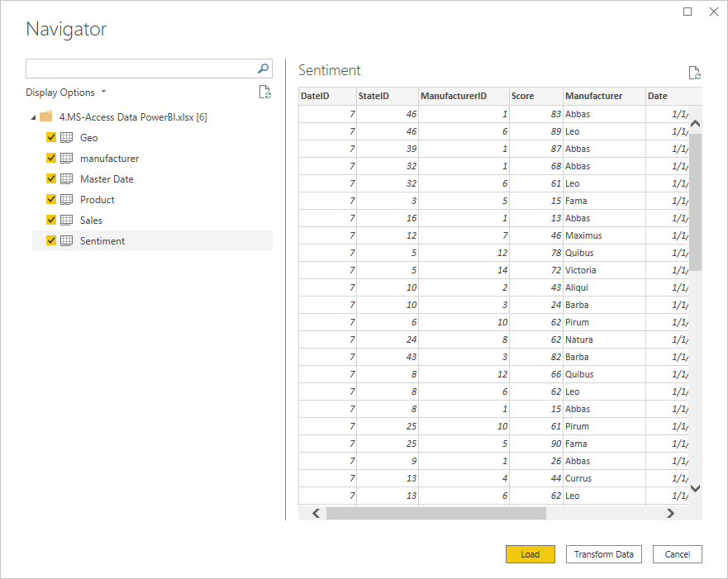

1. Upload the Folder from International Folder… [ there are four files in folder]

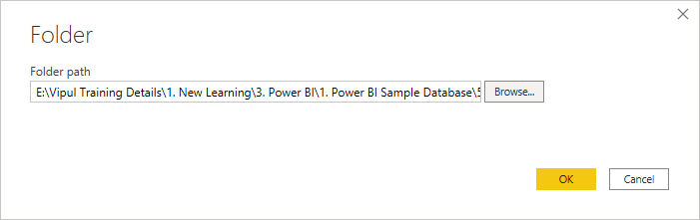



**Click on Combine and Load**

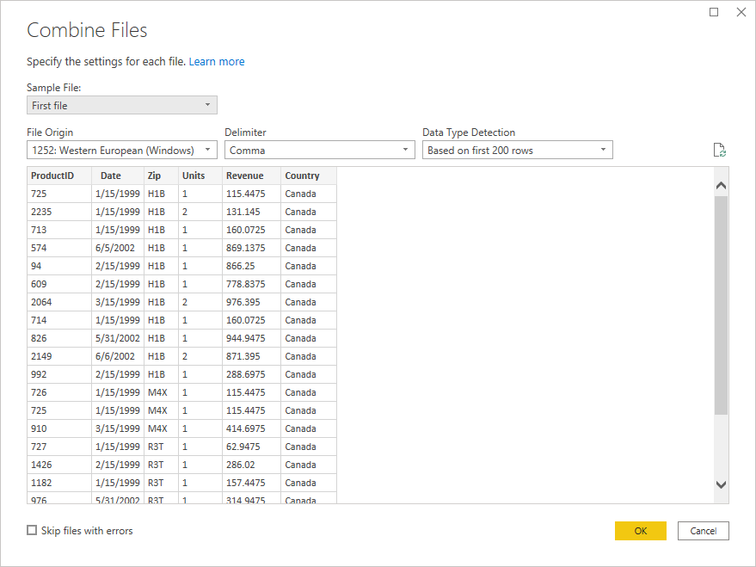

**Click OK**

1. **Append the Record from the International Query to Sales Table**
   1. Clock on Home- Transform Data
   2. Select Sales Query
   3. Click on Home- Append Query

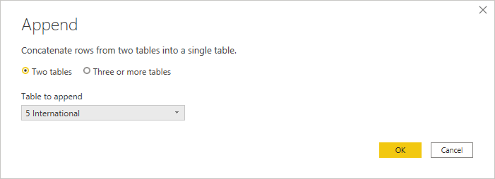

* 1. Click on OK.
  2. Remove the Col Source name from Sales Query [ Right click on Col Source name – remove]
  3. Replace null value by USA in Country Col .. in Sales Query [Right click on Value]

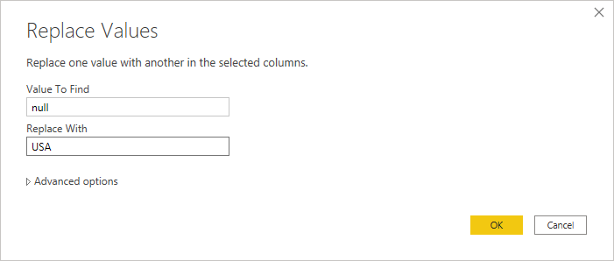

1. Add Few Col in Date Table [Week Number and Week Day]
   1. Make a Copy of Date Col [twice]
   2. One Date col replace with Week of the Year [ Transform- Date – Week – Week of the Year] and Rename Col to Week Number
   3. Select another Date [ Transform- Date – Day – Name of the day] and Rename Col to Week Number
2. Graphical user interface, application

   Description automatically generatedSelect the Product Query [ We want to split manufacturer name and Product code]
   1. Make a copy of Product Column
   2. Right Click and Split Col
3. Remove the Col Product Copy1
4. Rename another Col to Product code
5. Check the Links .. [Click Sales Date to Date Table and Geo table is not link..

Creating Reports

Create YTD Report using Dax Function.

* Select Matrix Visual add Year in Row and Revenue as value
  + Add Calculated filed YTD Revenue: TotalYTD(sum(sales[Revenue]),'Master date'[date])
  + Last Year YTD:   
    LYTD Revenue: = CALCULATE([YTD Revenue],SAMEPERIODLASTYEAR('Master date'Date]))
  + Sales Var for YTD: Variance = ( [YTD Revenue]-[LY YTD])
  + % of Sales Var YTD: Growth = DIVIDE([Var],[LyYTD revenue])
  + Add YTD Revenue, LYTD Revenue
* Select Visual of Water fall Chart
  + Add Year in Category and Growth in Values

**Create a Hierarchy Report**

1. Graphical user interface, application

   Description automatically generatedCreate a Hierarchy Report Year / Qtr/ month.. sales revenue and add Average sales revenue.
   1. Select Col Chart and Add Date from Master date table and Revenue from sales Table.
   2. Click on Analytics below visualisation and Select Average Line and Format it
2. Create a Hierarchy Category / Segment / Manufacturer wise [ Total units]
   1. Right Click on Field Category and Select Create Hierarchy
   2. Add Segment and Manufacturer in same Hierarchy.
   3. Create Pie Chart .. Add Hir.. and Units on Value

Create a Scatter Chart Report

* Select Visual Scatter
* Add Category in Details, Manufacture in Legend , Revenue in X-axis, Units in Y-axis , Size in Revenue and year in play axis

**Create KPI Report for Year 2014**

* Create a Calculated Field
* Total Revenue: Total Revenue = Sum([Revenue])
* Total Units : Sum([Units])
* Total Units sold by Vanarsdel :  
   Total unit sold of VAnArsdel = CALCULATE(SUM([Units]),Manufacturer[Manufacturer]="VAnArsdel")
* Use Card Visual for calculated Field.
* Use Gauge Visual .. Add a Target Value
* Add additional Visual Word Cloud …
* Use Funnel Chart for Month wise Revenue.
* Country wise Revenue in Map Visual
* Add Category wise Revenue.
* Add Slicer for Country wise

**Create a Report using Drill Through.**

1. 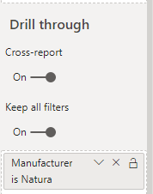Create two reports Manufacturer wise Revenue and in second page show details according to Manufacturer wise in matrix report[name: Details Report]
2. In first report keep Filter on and cross Filter on
3. In Second sheet [Details sheets] keep filter on and add field name Manufacture
4. Go to first report, right click on Manufacturer

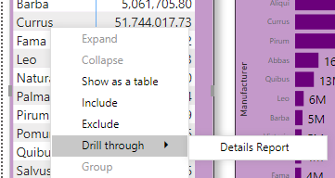

B

**Use Hyperlink and Bookmark**

* Click on Insert Button and select Blank.
* Graphical user interface, application

  Description automatically generatedFormat and add text.
* Select YTD Report
* Click on View- Bookmark -Select Chart and Add Bookmark
* Select Hyperlink Sheet ..
* Graphical user interface, text, application

  Description automatically generatedSelect Button and In Format add Action.

Create a Decomposition Chart

Create a Tree Chart

